January 2017

Application for stay or interim order
ADMINISTRATIVE AND EQUAL OPPORTUNITY DIVISION AND OCCUPATIONAL DIVISION
File Number
Office use only

PARTIES
Applicant/Appellant
Respondent

ORDERS SOUGHT

GROUNDS FOR APPLICATION OR ORDER

SIGNATURE
Your signature or signature of legal representative
Name
Signature Date

NOTICE OF LISTING Office use only
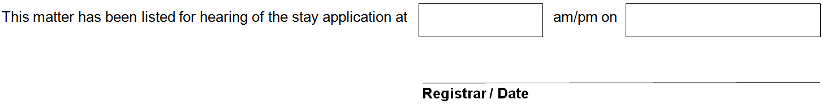

REGISTRY DETAILS

NCAT Administrative and Equal Opportunity Division and Occupational Division
Postal address: PO Box K1026, Haymarket NSW 1240
DX 11539 Sydney Downtown
Street address: Level 10 John Maddison Tower, 86-90 Goulburn Street, Sydney NSW 2000
Telephone: 1300 006 228
Email: aeod@ncat.nsw.gov.au
Website: www.ncat.nsw.gov.au

